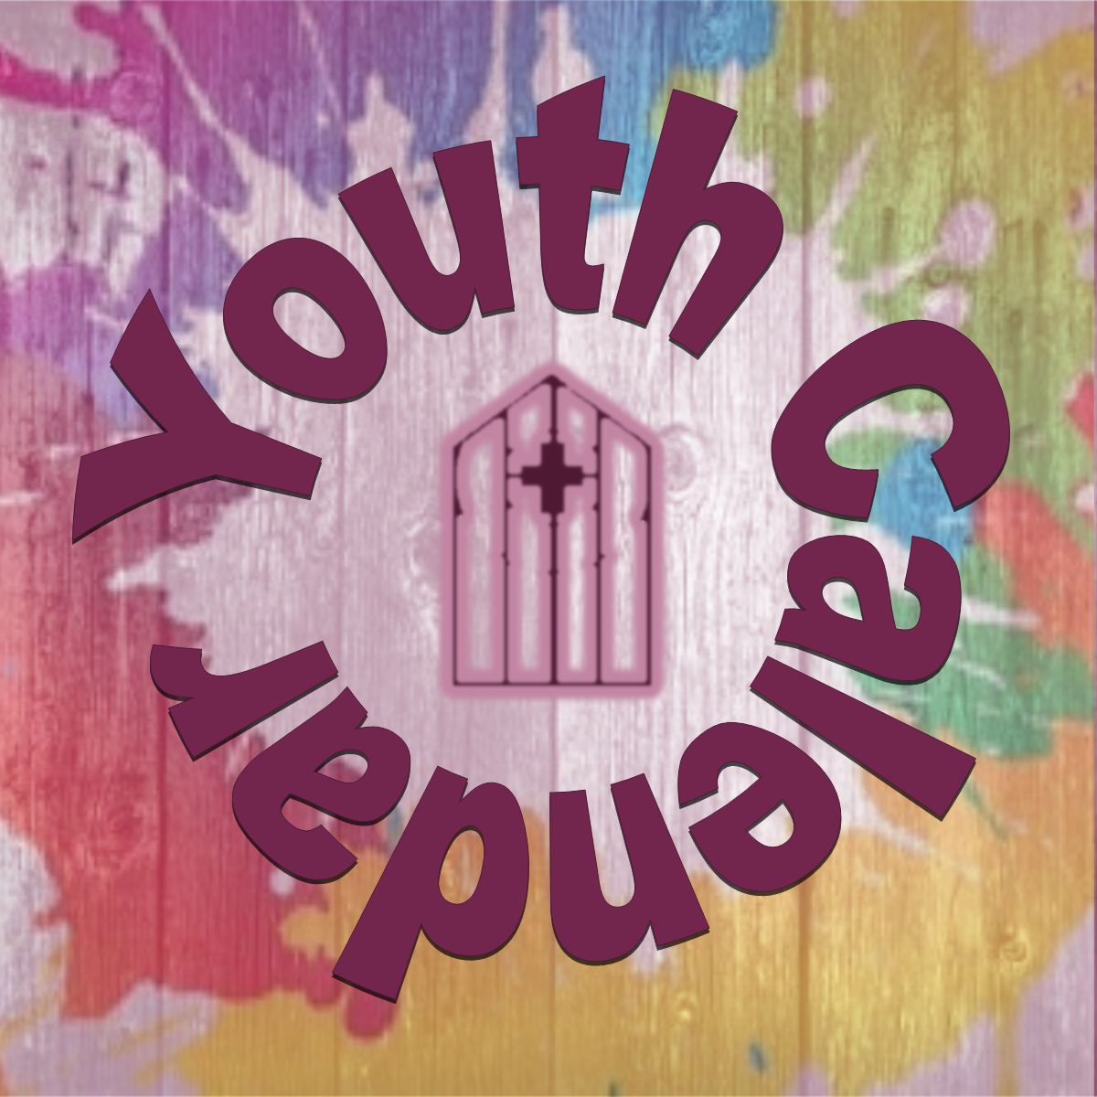
Hello Everyone!
Below is the Covenant Youth Schedule for the Fall! If everyone is able to RSVP to events with a Yes or a No as soon as possible; it really helps with planning and could (potentially) increase my effectiveness in organizing the group. These activities are designed for youth in grades 6th through 12th, but, as always, exceptions can be made! Please reach out to me if you would like to come and/or a sibling would like to join!
Sunday, September 15th—Wild Life Sanctuary Faith Trip: Immediately after worship. Pick up 4:00 PM at Covenant. Cost: $15/person, includes lunch. Youth will travel to the Wild Life Sanctuary in Keenesburg, CO to learn about the growing endangered species list and what our faith teaches us about caring for all creatures.
Sunday, October 6th—Service Day at “The Land” - Immediately after worship. Pick up at 2:00 PM. No Cost/Brown Bag Lunches provided. Youth must wear old sneakers, jeans, hat and bring a water bottle/sunscreen/bug spray. Youth will learn about the relationship between faith and care for creation as we learn about composting and care for the prairie ecosystem.
Sunday, November 3rd—Afternoon at IMAX (Pizza lunch at Covenant). Immediately after worship. Pick up time TBD. Cost: $15/person. Youth will watch an IMAX movie connecting them with the beauty of creation to expand on our past two outings.
Sunday, December 15th—Youth Christmas Bowling Party and Lunch! Immediately after worship. Pick up 2:00 PM at Covenant. Cost: $10/person (plus $10 gift to exchange).
It’s going to be a great year!!
Rev. Stephanie L. Price, Children and Youth Director—720-955-4799 (cell) stephanie@covenantdtc.org

